Hasil Running :

* array.js

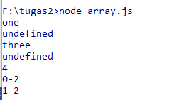

* breakContinue.js

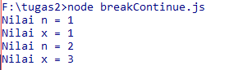

* breakWithLable.js



* const.js

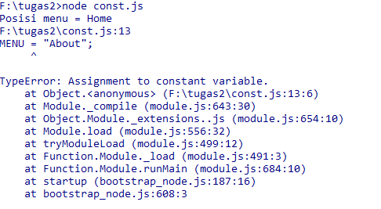

* doWhile.js

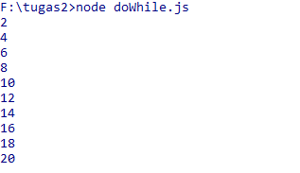

* dynamic.js



* for.js

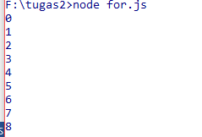

* forIn.js

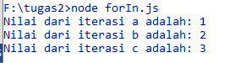

* fungsiAnonim.js



* fungsiRekursif.js



* if.js

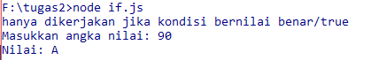

* json.js



* nested.js

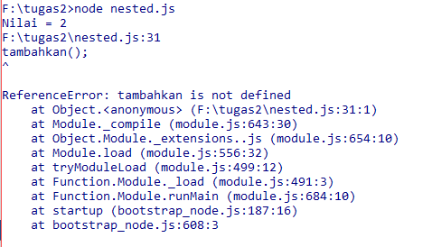

* readline.js



* switch.js

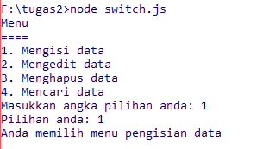

* throw.js



* try.js



* while.js

